Import Data Using Transform Maps (spreadsheet)
A Project Report Submitted in Partial Fulfillment of the Requirement for the Award of the Degree in

BACHELOR OF COMPUTER APPLICATIONS
Submitted By
S. Devi (Leader) 24083270500112106
S . Arthi 24083270500112102
T. Lavanya 24083270500112112
R. Janani 24083270500112108
S. Jeya lakshmi 24083270500112109

VIVEKANANDA COLLEGE OF ARTS AND SCIENCE
KANNIYAKUMARI
(Affiliated to MANONMANIAM SUNDARANAR UNIVERSITY, Tirunelveli)

DECLARATION

I hereby declare that the project titled “Import Data using Transform Maps (Spreadsheet)” is prepared as part of my academic project work. The project demonstrates the implementation of importing employee data from a spreadsheet into ServiceNow using Import Sets and Transform Maps. I have prepared and documented the project based on the work carried out during the project period and have presented the implementation, testing and results accurately to the best of my knowledge.

ABSTRACT
The project titled “Import Data using Transform Maps (Spreadsheet)” focuses on importing structured employee data from an external spreadsheet into the ServiceNow platform. The project uses Import Sets as a staging area and Transform Maps to map source spreadsheet fields to the appropriate fields in a custom Employee Test table. The imported data is transformed and validated to ensure accurate record creation. Coalesce is also used to identify existing employee records and prevent duplicate entries during repeated imports. Reports and a dashboard are created to provide a clear view of employee data. This project demonstrates the complete process of data loading, field mapping, transformation, validation, duplicate handling, reporting and visualization in ServiceNow.

Table Of Contents

S. No. | Phase | Page No.
1 | Brainstorming & Ideation Phase | 1
2 | Requirement Analysis Phase | 3
3 | Project Design Phase | 4
4 | Project Planning Phase | 6
5 | Project Development Phase | 8
6 | Project Testing Phase | 10
7 | Project Documentation Phase | 11
8 | Project Demonstration Phase | 13
9 | Conclusion | 14

1. Brainstorming & Ideation Phase

1. Overview
The project idea is to create an efficient method for importing employee data from an external spreadsheet into ServiceNow. Manual entry of bulk employee information can be time-consuming, so the project uses Import Sets and Transform Maps to provide a structured import process.
The proposed solution starts with employee data prepared in a spreadsheet. The spreadsheet is loaded into an Import Set table, which acts as a staging area. A Transform Map then connects the source fields with the corresponding fields in the Employee Test target table.

2. Key Activities
- Import employee data from an external spreadsheet.
- Use an Import Set as a staging area.
- Map spreadsheet fields to the ServiceNow target table.
- Transform the imported data into employee records.
- Use Coalesce to avoid duplicate records.
- Create reports and a dashboard.

3. Detailed Process
In this phase, the project work related to **Brainstorming & Ideation Phase** is carried out according to the overall ServiceNow project workflow. The activities are recorded in sequence so that the implementation can be understood and demonstrated clearly.

4. Expected Outcome
The phase should produce a clear and documented output that can be verified before moving to the next phase. The project remains focused on importing spreadsheet employee data into ServiceNow using Import Sets and Transform Maps.

5. Project Evidence / Screenshots
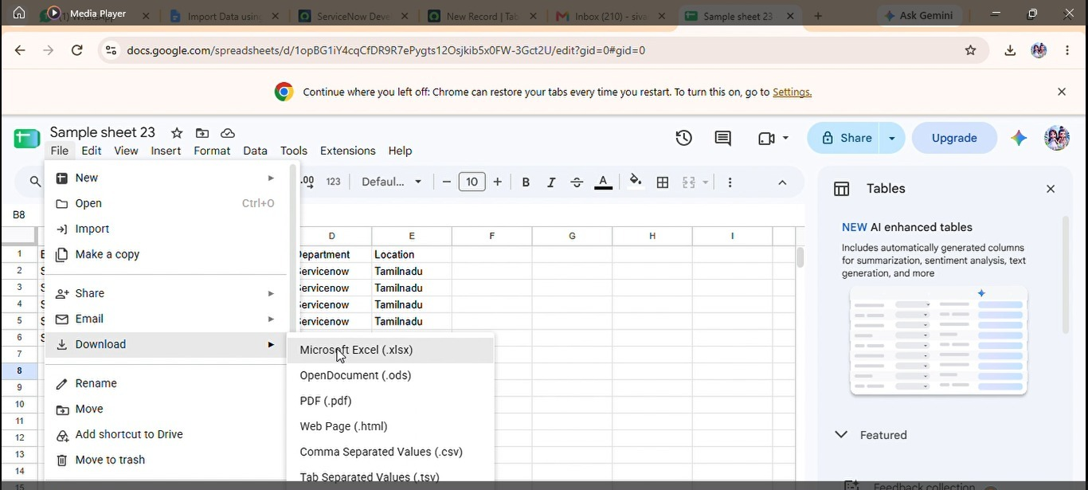

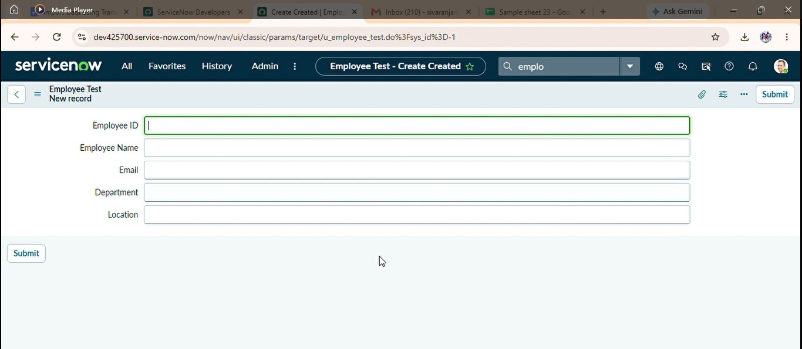

6. Phase Summary
Phase 1 completes the activities required for Brainstorming & Ideation Phase. The documented output and screenshots provide evidence of the project work and support the transition to the next phase.

